Briefing Document for AI-ML / GenAI Powered Post-Race Media Optimiser

Objective:
To develop an AI-ML/GenAI-powered Post-Race Media Optimiser solution that automates the curation, scoring, tagging, and publishing of post-race media assets (photos, videos, audio). The system leverages computer vision, NLP, and generative AI to improve storytelling efficiency, PR comms, sponsor visibility, and content impact across social, press, and internal platforms.

Key Capabilities:
- Media Clustering: Automatically group media assets into themes (e.g., podium, fan reactions, driver highlights).
- Asset Scoring: Evaluate assets based on sponsor visibility, emotional resonance, lighting, and context.
- GenAI Captions & Summaries: Generate sponsor-ready social/PR copy and summaries.
- NLP & Speaker Insight: Extract quotes and sentiment from race-day audio using speech-to-text + NLP.
- DAM Integration: Direct publishing, tagging, and metadata handover to SharePoint/Imagen.
- Performance Benchmarking: Predict and compare media effectiveness post-publication.

System Architecture:
- Input Layer: Media ingestion (photos, videos, audio).
- AI Core Layer: Clustering, sponsor/logo detection, emotion analysis, captioning, asset scoring.
- Output Layer: Dashboard for review/approval and API integrations with SharePoint/Imagen.
- Monitoring Layer: Analytics dashboard for performance benchmarking.

Wireframe of the AI-ML / Gen AI Powered Post-Race Media Optimiser
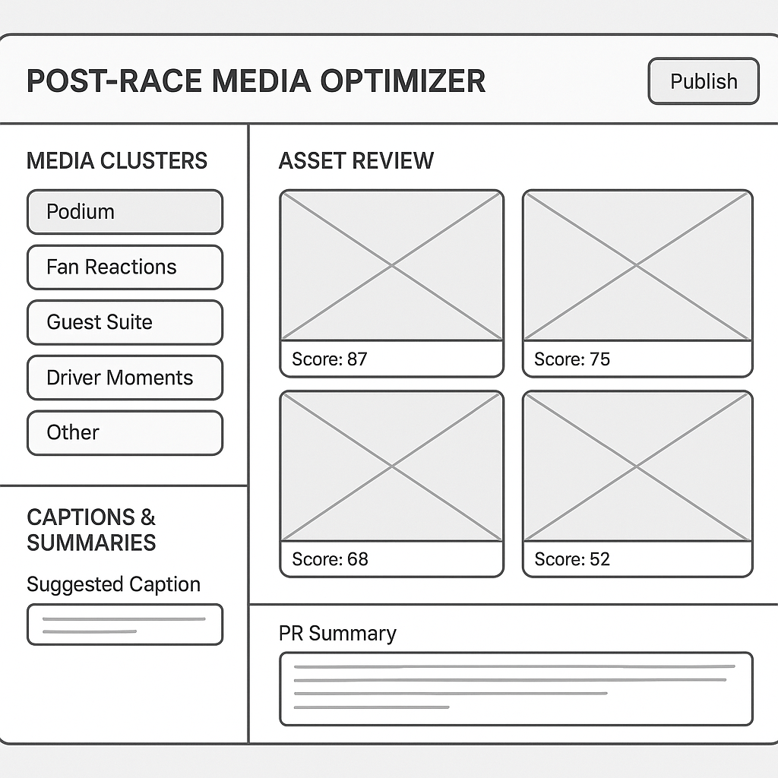

Project Development Phases & Timelines:
Phase 1: Discovery & Input Stream Setup (Weeks 1)
- Define ingestion sources (broadcast, on-ground media, social).
- Build sponsor dataset & campaign metadata repository.
- Confirm storage and DAM integration requirements.
Phase 2: Media Processing AI Layer (Weeks 2-3)
- Develop clustering using embeddings.
- Train & fine-tune emotion detection models.
- Create sponsor/logo detection classifiers.
- Integrate Whisper/NLP for quote extraction & sentiment tagging.
Phase 3: Asset Scoring & Ranking (Weeks 3–5)
- Implement scoring logic (sponsor visibility, emotion, lighting, context).
- Normalize & rank assets for priority selection.
Phase 4: GenAI Copywriting Layer (Weeks 5–6)
- Integrate GPT-based captioning & summarization.
- Customize outputs by tone, audience, and sponsor requirements.
- Add alt text generation for accessibility.
Phase 5: Integration with Publishing Tools (Weeks 6-7)
- Build APIs for SharePoint/Imagen metadata tagging & publishing.
- Enable filtering by sponsor, race, priority, and channel.
Phase 6: UI Console Development (Weeks 7-8)
- Develop reviewer/approver dashboard.
- Provide asset preview, filters, and GenAI caption regeneration.
- Role-based access & workflow approvals.
Phase 7: Testing & QA (Weeks 8-10)
- Unit & integration testing across all modules.
- Validate GenAI content (quality, tone, sponsor compliance).
- Security, privacy, and performance testing.
Phase 8: Deployment & Monitoring (Weeks 10–12)
- Containerize with Docker.
- Deploy on Azure or equivalent Cloud infra with Monitor & CI/CD pipelines.
- Build analytics dashboard for benchmarking media effectiveness.
- Implement ongoing monitoring & retraining pipeline for AI models.

Indicative Timeline (12 Weeks / ~3 Months):
- Month 1: Discovery + Media AI Layer kick-off + Sponsor/logo detection, clustering, NLP integration.
- Month 2: Scoring, Ranking, GenAI copywriting.
- Month 2-3: Publishing integrations + UI console.
- Month 3: Testing, deployment, monitoring.

Gantt Chart for AI-ML / GenAI Powered Post-Race Media Optimiser
JTR AI-Study Project Development Phases & Timelines
Weeks | 1 | 2 |  | 3 |  | 4 |  |  | 5 |  | 6 |  |  | 7 |  |  | 8 |  | 9 |  | 10 | 11 |  | 12
Phases
Phase 1: Discovery & Input Stream Setup | 1 | 0 |  | 0 |  | 0 |  |  | 0 |  | 0 |  |  | 0 |  |  | 0 |  | 0 |  | 0 | 0 |  | 0
Phase 2: Media Processing AI Layer | 0 | 1 |  | 1 |  | 0 |  |  | 0 |  | 0 |  |  | 0 |  |  | 0 |  | 0 |  | 0 | 0 |  | 0
Phase 3: Asset Scoring & Ranking | 0 | 0 |  | 1 |  | 1 |  |  | 1 |  | 0 |  |  | 0 |  |  | 0 |  | 0 |  | 0 | 0 |  | 0
Phase 4: GenAI Copywriting Layer | 0 | 0 |  | 0 |  | 0 |  |  | 1 |  | 1 |  |  | 0 |  |  | 0 |  | 0 |  | 0 | 0 |  | 0
Phase 5: Integration with Publishing Tools | 0 | 0 |  | 0 |  | 0 |  |  | 0 |  | 1 |  |  | 1 |  |  | 0 |  | 0 |  | 0 | 0 |  | 0
Phase 6: UI Console Development | 0 | 0 |  | 0 |  | 0 |  |  | 0 |  | 0 |  |  | 1 |  |  | 1 |  | 0 |  | 0 | 0 |  | 0
Phase 7: Testing & QA | 0 | 0 |  | 0 |  | 0 |  |  | 0 |  | 0 |  |  | 0 |  |  | 1 |  | 1 |  | 1 | 0 |  | 0
Phase 8: Deployment & Monitoring | 0 | 0 |  | 0 |  | 0 |  |  | 0 |  | 0 |  |  | 0 |  |  | 0 |  | 0 |  | 1 | 1 |  | 1

Link to above Gantt chart:

